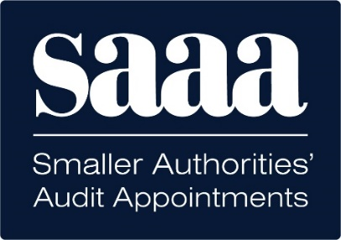
SAAA Digital AGAR Project
Seeking Expressions of Interest from Prospective Suppliers

Project Overview and Scope

Smaller Authorities' Audit Appointments Ltd (SAAA) is seeking qualified IT suppliers to submit expressions of interest for the Digital AGAR (Annual Governance and Accountability Return) Project. This transformative initiative aims to modernise the annual audit submission process for over 9,800 smaller authorities across England, replacing the current paper-based system with a comprehensive digital platform. The successful supplier will be responsible for system development, hosting and support of a web portal that streamlines form selection, completion, validation, and submission processes while providing secure access for authorities, external auditors, and SAAA administrators. This solution will eliminate manual data entry errors, reduce processing time, and create a standardised data transfer format for integration with audit firms' back-office systems.

Supplier Requirements and Qualifications

Prospective suppliers must demonstrate extensive experience in developing secure, cloud-based web applications. We require evidence of expertise in online form development, system hosting and support, user authentication systems, database design and accessibility standards (WCAG 2.2 AA). We therefore seek a technology partner to work with us on this innovative project and are searching for an IT company with proven experience in government digital service (GDS) guidelines, multi-user portal development, and integration capabilities for data exchange with external systems. References from similar UK projects will be essential.

Submission Process and Evaluation Criteria

Expressions of interest must be submitted by 5pm on Wednesday 16 July 2025 via email to digital@saaa.co.uk. The Invitation to Tender (ITT) document will be issued to prospective suppliers during the second half of July with a deadline for tender responses seven weeks after the issue date and with further instructions provided in the ITT. Our tender evaluation will be based on; understanding of requirements, innovation with digital online form solutions, experience, approach to hosting and support approach, delivery timeline capability, and overall value proposition.

Next Steps and Timeline

All prospective suppliers who respond to this notice for expressions of interest will be issued the Invitation to Tender in July 2025. Our intention is to select a preferred supplier by September 2025 with contracts signed by the following month. The successful supplier must deliver a functional pilot system by March 2026 with system hosting and support arrangements to commence once the pilot is operational. All submissions will be treated confidentially, and the SAAA Tender Evaluation Panel will provide recommendations to the SAAA Board for final approval.

For now, simply email digital@saaa.co.uk indicating your expression of interest and contact us if you have any questions or require further information.

