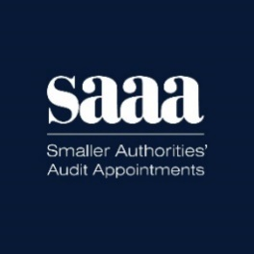

SAAA Board – pen portraits
26 Mar 2024

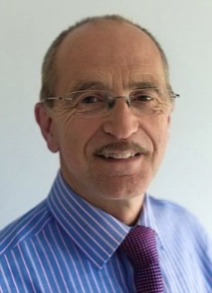
David Bowles (Chair) 2023
A CIPFA qualified accountant, David has extensive experience in the public and private sectors including Chief Executive of four different Councils, notably Lincolnshire County Council. More recently he conducted special investigations and reviews into complex governance matters in the NHS and local government, often issuing public reports. He has strong Non-Executive Director experience including the Audit Committee of CIPFA and Chair of a large NHS Acute Trust in England. He is currently a Non-Executive Director with the National Police Chief’s Council, on their Audit and Assurance Board, and is on the Council of Protect, the whistleblowing charity

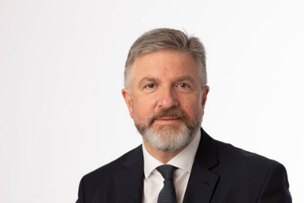
Chris Pope OBE (Independent Director) 2023
After a full career in the Army, Chris spent four years in the private sector and subsequently held several senior posts in London Boroughs chairing the East London Councils procurement board and initiating the merger of Newham and Havering Council support services becoming the first MD of their joint venture. He joined the Civil Service as Commercial Director at the Department for Business, Innovation and Skills responsible for procurement and supply chain management of the department and his last role was as Chief Operations Officer of HM Land Registry.

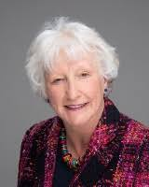
Elizabeth (Liz) Sandwith (Independent Director) 2023
Liz is and Internal Audit and Risk Consultant. She has been a Head of Internal Audit for several private, financial services and public sector organisations. She recently became a member of a Multi Academy Trust Board, Chair of Governors for a Local Accountability Board and Chair of the Audit and Risk Committee. For 6 years previously she was a Board member, Deputy Chair and Chair of the audit and risk committee of a Leeds based Social Housing Association. In 2020 Liz was awarded the JJ Morris Distinguished Service Award recognises members who have given unusual and outstanding service to the internal auditing profession.

Andrew Davies (Independent Director) 2023
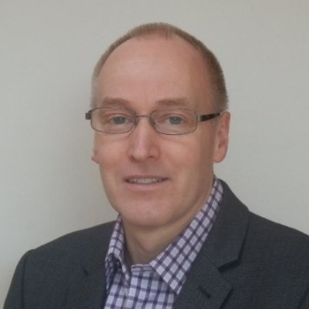
Andrew has extensive experience of the public (including regulated audit), private and voluntary sectors. He was a senior manager at the Audit Commission from 2000 to 2013, responsible for procuring and appointing auditors to public bodies (including smaller authorities), contract compliance and setting of statutory audit fees. From 2013 to 2023 Andrew was an ombudsman for the Financial Ombudsman Service and, since 2017, has supported SAAA’s quality review process.

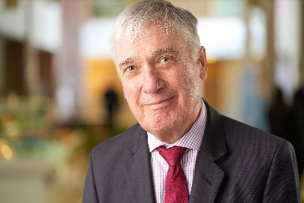
Martin McNeill (Independent Director)
Formerly Director of Management Services at the Audit Commission, Martin advised the Commission on the design of its procurement model for audit services, including the limited assurance regime for smaller authorities. He currently works as a governance consultant in further education and is a governor of Petroc College (North Devon) and a Council Member of Birmingham Newman University.

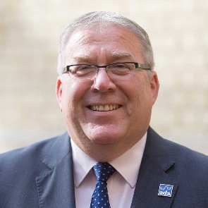
Peter Bateson (Member Director – Association of Drainage Authorities)
An FCCA qualified accountant, Peter spent 15 years with Deloitte advising private client businesses and was heavily involved in graduate recruitment and interviewer training. He has experience in private sector Finance Director roles and legal practice management, obtaining an MBA from Nottingham Law School in 2009. He moved into the public Sector and has spent the last 15 years as CEO for a large Lincolnshire Drainage Board. He is Company Secretary for the Association of Drainage Authorities (ADA) and is their Member Director on SAAA Ltd. He is part of the ADA team delivering the updated ‘Good Governance Guide’ for Drainage Board Members. He recently stood down as an ACCA Public Sector panel member but has experience as a finance trustee for a number of charities including HomeStart UK and Lincolnshire CVS, and he is Chairman of a local Community Centre Charity.

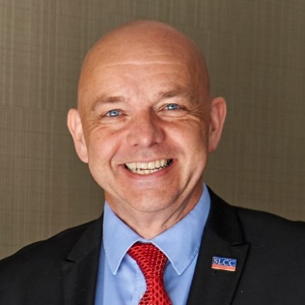
Michael King (Member Director – Society of Local Council Clerks)
Michael is the Town Clerk of Whitby in North Yorkshire and an elected regional director of the Society of Local Council Clerks since 2017. He graduated in the Science of Engineering Materials, holds an MBA and is a Fellow of the Chartered Management Institute. He has worked in research, public policy and management positions in local authorities, the NHS and in consultancy. His career experience includes programme and project management, corporate governance, strategy development and performance management

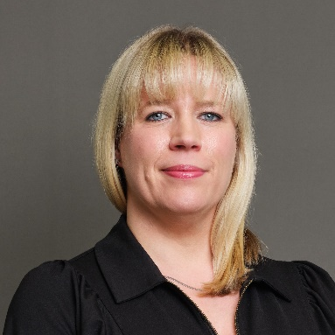
Charlotte Eisenhart (Member Director Designate – National Association of Local council)
Charlotte Eisenhart joined NALC in 2019, taking on the role of head of member services. Throughout her career, she has been passionate about supporting people's efforts to make change in their communities, whether through leadership development programmes for councillors or engaging people in social change work. Her previous roles include head of engagement at the Royal Society for the Encouragement of Arts, Manufactures and Commerce, adviser at the Local Government Association and political officer at the Leadership Centre for Local Government. She is also a trustee at the perinatal mental health charity PANDAS.

